AI POWERED MENTAL HEATLH DIAGNOSIS

**Md Sayeed1,** **S Bala Sree Varsha2, P Hari Sai3, S Vyshnavi4,** **K Jahnavi5**

Assistant Professor, Dept.of.CSE Artificial Intelligence and Machine Learning, VVIT, GUNTUR, AP, INDIA1

Student, Dept.of.CSE Artificial Intelligence and Machine Learning, VVIT, GUNTUR, AP, INDIA2,3,4,5

**Abstract**:

Digitization speed in our current era shows mental health problems growing as a vital dilemma which particularly affects workers in demanding professional roles. The AI-Driven Mental Health Diagnosis platform performs mental health condition predictions through advanced machine learning algorithms which process user inputs as well as analyse behavioural patterns together with historical data. The system creates comprehensive mental well-being assessments through its ability to evaluate formatted data and free-form information about symptoms with added lifestyle conditions and workplace stress elements. The platform achieves this through exploratory data analysis methods which both reveal dominant patterns and danger elements behind mental health deteriorations.

The predictive system uses multiple machine learning approaches which combine logistic regression with decision trees and random forests and neural networks for mental health condition diagnosis and prediction tasks. The AI-powered chatbot receives support from natural language processing (NLP) through Google Dialog flow to offer immediate relaxation techniques and music suggestions and yoga exercises to users. The platform allows users to track their mental health progress through an interactive control centre that provides AI-generated personalized reports and downloadable assessments.

The system activates automated alert systems together with individual recommendations to simultaneously detect mental health warning indicators while implementing prompt assistance for better well-being. The platform combines AI analytics with chatbot equivalent and interactive tracking capabilities to establish itself as a groundbreaking instrument which boosts mental health education while providing active time-based help for those needing assistance.

Keywords: AI-driven mental health diagnosis, machine learning algorithms, mental well-being, behavioural patterns, exploratory data analysis (EDA), predictive modelling, natural language processing (NLP), real-time support, personalized recommendations, interactive dashboard, mental health tracking, early intervention, stress management, workplace well-being.

1. **INTRODUCTION**

The current global trend shows an increase of mental health problems particularly among those working in high-stress industries like technology. This research presents an artificial intelligence solution which detects mental health disorders through assessing user inputs together with their patterns of behaviour and previous records. The system supports real-time interactions while using NLP and machine learning with an interactive dashboard to track user mental well-being.

1. The initial step of the project involves importing pandas, NumPy, sklearn, and matplotlib libraries for handling and analysing the dataset having 1259 rows and 27 columns. The Exploration of Data Analysis procedure reveals significant patterns through which mental health predictive elements are determined.

2. The development of a mental health prediction system includes using a combination of logistic regression as well as decision trees along with random forests and bagging classifiers. The model evaluation uses standard performance metrics which include accuracy alongside precision, recall and F1-Score.

3. Mental health risk assessment depends on three key features collected from the dataset: text analysis, user responses, and work-related stress factors. Training of the model requires these fundamental features to recognize possible mental health conditions.

4. The detection of a mental health risk halts the system to trigger warning alerts along with suggested actions.

• Music for relaxation,

• Yoga exercises,

• Mood-based relaxation techniques.

5. The platform offers its users interactive access to a dashboard that has several functionalities.

Users must perform two functions: register their mental health state and allow continuous monitoring of their condition throughout time.

Users gain instant help from an intelligent chatbot supported by Artificial Intelligence.

Users benefit from the system capability to generate reports while offering feedback regarding the system performance.

6. The integration of Google Dialog flow within the chatbot platform improves user interaction by letting the system provide custom recommendations for moods and relaxation methods and music selection from user responses.

The AI system uses NLP and machine learning technologies to provide active mental health management solutions to users. Users can use this tool to monitor their mental health status along with receiving customized support and tracking their progress as it proves effective for improving well-being in stressful conditions.

.

1. **LITERATURE SURVEY**

Mental health issues are a growing concern, especially in high-stress environments such as the tech industry. The use of artificial intelligence (AI) and machine learning (ML) has shown significant potential in detecting and managing mental health conditions. **Liu et al. (2020)** demonstrated that machine learning algorithms, such as logistic regression and decision trees, could predict mental health conditions based on behavioural data and self-reported symptoms. Their findings highlight the effectiveness of AI in early mental health detection, providing a timely warning for intervention [1].

The integration of Natural Language Processing (NLP) with chatbots has also been explored as a tool for mental health detection. **Shatte et al. (2019)** utilized NLP to analyse user inputs and identify emotional distress. Their approach allowed for personalized real-time interventions such as relaxation exercises and mindfulness practices, proving that AI can offer tailored support based on individual responses [2].

Mobile-based AI systems have further expanded the potential for mental health monitoring. **Fitzpatrick et al. (2017)** developed an AI tool that tracks daily activities and provides real-time mental health recommendations, which significantly reduced stress levels. This approach demonstrated the power of continuous data collection through smartphones in improving emotional well-being [3]. **Sweeney et al. (2018)** also examined AI-driven personalized interventions and found that when interventions are tailored to users' emotional states, they lead to better stress management and overall well-being [4].

Despite these advancements, challenges such as integrating multimodal data for mental health assessments remain. **Hassan et al. (2021)** discussed the potential of combining text, voice, facial expressions, and physiological data to improve mental health detection. This approach addresses the limitations of using a single data source and provides a more holistic understanding of a user's mental state [5]. Similarly, **Sriram et al. (2020)** demonstrated that deep learning models can effectively process large datasets, allowing for more accurate predictions and enhanced mental health management [6].

The use of AI for mental health diagnostics has also raised ethical concerns. **Chung et al. (2021)** explored the privacy and security issues related to the use of personal data in AI systems. As AI models collect sensitive information, ensuring robust data protection is critical to maintaining user trust and privacy [7]. Additionally, **Bakker et al. (2020)** focused on using AI to detect burnout and stress in workplace environments. Their study suggested that AI could analyse work-related data, such as workload and communication patterns, to identify employees at risk and provide timely interventions [8].

Moreover, **Gaffney et al. (2019)** highlighted the role of NLP-powered chatbots in providing accessible and real-time support to individuals facing mental health challenges. These chatbots can process natural language and deliver tailored suggestions, making them a valuable tool for providing continuous support to users who may otherwise feel uncomfortable seeking help [9].

In conclusion, AI-based systems are an innovative solution for detecting and managing mental health conditions. Through the integration of machine learning, NLP, and personalized recommendations, these systems offer real-time support and improve overall mental well-being. However, challenges such as data privacy, integration of multimodal data, and ensuring personalized care remain important areas for future research [10].

1. **METHODOLOGY**

The AI diagnosis system adopts a sequential approach which includes patient data collection and model development to enable effective condition detection along with real-time user assistance by utilizing user input and behavioral records. The full process embeds data collection into its beginning stages while processing and model development happens in sequence before implementing real-time user support functions. The following description details all steps of the process.

1. **Data Collection and Preprocessing**

The system development begins by collecting mental health-related information about symptoms with emphasis on lifestyles habits combined with work stress factors and user feedback. Users provide their data through surveys where they either fill in structured questionnaire sections consisting of demographic details or respond with unstructured free-text inputs. A data cleaning process follows data collection to ensure the information becomes ready for analysis needs. The data pre-processing stage comprises dealing with missing data points along with variable encoding and numerical feature normalization.

**Dataflow:**

The stage begins with data preprocessing until it reaches feature extraction after processing multiple steps starting from user input. The goal within this stage is to make the data appropriate for both analysis and modelling. The following picture shows data moving between these operational stages.

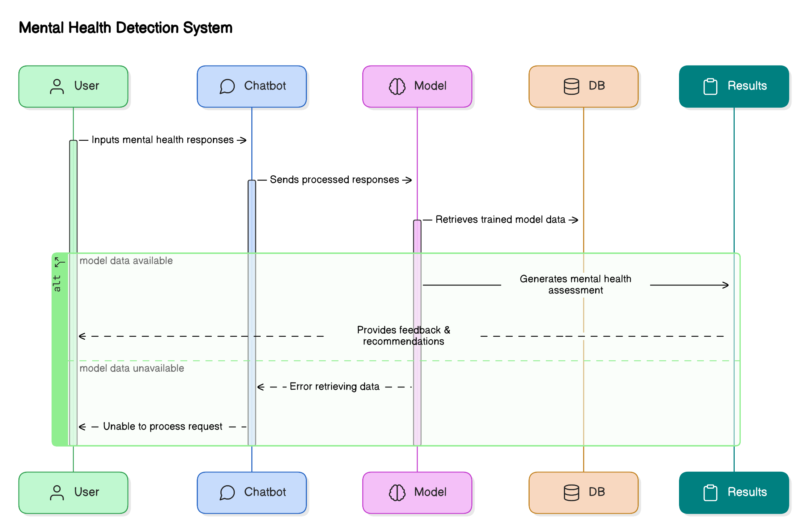

*Figure 1: Dataflow in the mental health detection system*

1. **Exploratory Data Analysis (EDA)**

Data pre-processing procedures lead to the performance of an exploratory data analysis (EDA). EDA reveals data patterns together with identifying any structural issues in the dataset. The phase relies on statistical methods together with visual data tools which include histograms and box plots and correlation matrices to find connections between different variables within the collected data. The system obtains better insights because it detects links between occupational stress factors and psychological symptoms through its analytical capabilities.

1. **Feature Selection and Engineering**

The selected key features will function as model input data following EDA results evaluation. The process of developing new features from existing data through feature engineering helps to improve model performance. Several derived features such as negative mood frequency reports and work habit patterns may assist in mental health prediction.

1. **Model Development**

Multiple machine learning models assess mental health conditions to make predictions from the chosen features during this stage. The different prediction models applied to mental health analysis consist of logistic regression together with decision trees and random forests and neural networks. Evaluation through different performance metrics including accuracy together with precision and recall and F1-score occurs after the dataset processing step for each trained model. The objective is to identify the most precise model which determines mental health diagnoses correctly from obtained information..

1. **Model Evaluation and Tuning**

Model evaluation begins after the completion of training processes. The testing set provides evaluation of model ability to predict new unseen data. The analysis of results helps to detect necessary areas for improvement. Variations of hyperparameters from the most successful model are adjusted to maximize its performance results. The combination of cross-validation together with grid search serves as techniques to generate an accurate and robust final model.

1. **Integration with NLP and Chatbot**

Nature Language Processing enables a chatbot to deliver real-time support and interactive sessions through the implemented system. Users obtain real-time mental health assistance through the chatbot by using NLP to process their chat inputs. The platform utilizes user responses to provide customized guidance which includes relaxation exercises together with yoga motions and suitable music recommendations.

During platform navigation the chatbot provides user feedback about mental health status and proposes stress management strategies to users. The NLP capabilities built into the system make sure the chatbot understands contexts so it can deliver valuable interactions for users.

1. **User Dashboard and Feedback**

The system contains a primary functionality of interactive user dashboard management. System users have the ability to monitor their mental health development after they complete account registration and login procedures. Through the dashboard interface users can assess their mental health background and monitor symptom shifts together with AI-generated mental health assessments of their condition. The system enables users to obtain detailed reports while allowing updating of personal information and offering a platform to post feedback about their usage of the system.

Systemwide enhancement relies on user experience feedback because it shapes how the system develops. The service uses this information to optimize its algorithms and create a more satisfactory digital encounter. Users can conveniently follow their mental health records and get real-time condition updates through the interface which provides a user-friendly design.

**System Flowchart:**

The flowchart below illustrates the overall system architecture, starting from data input, through model prediction, and ending with real-time support from the chatbot.

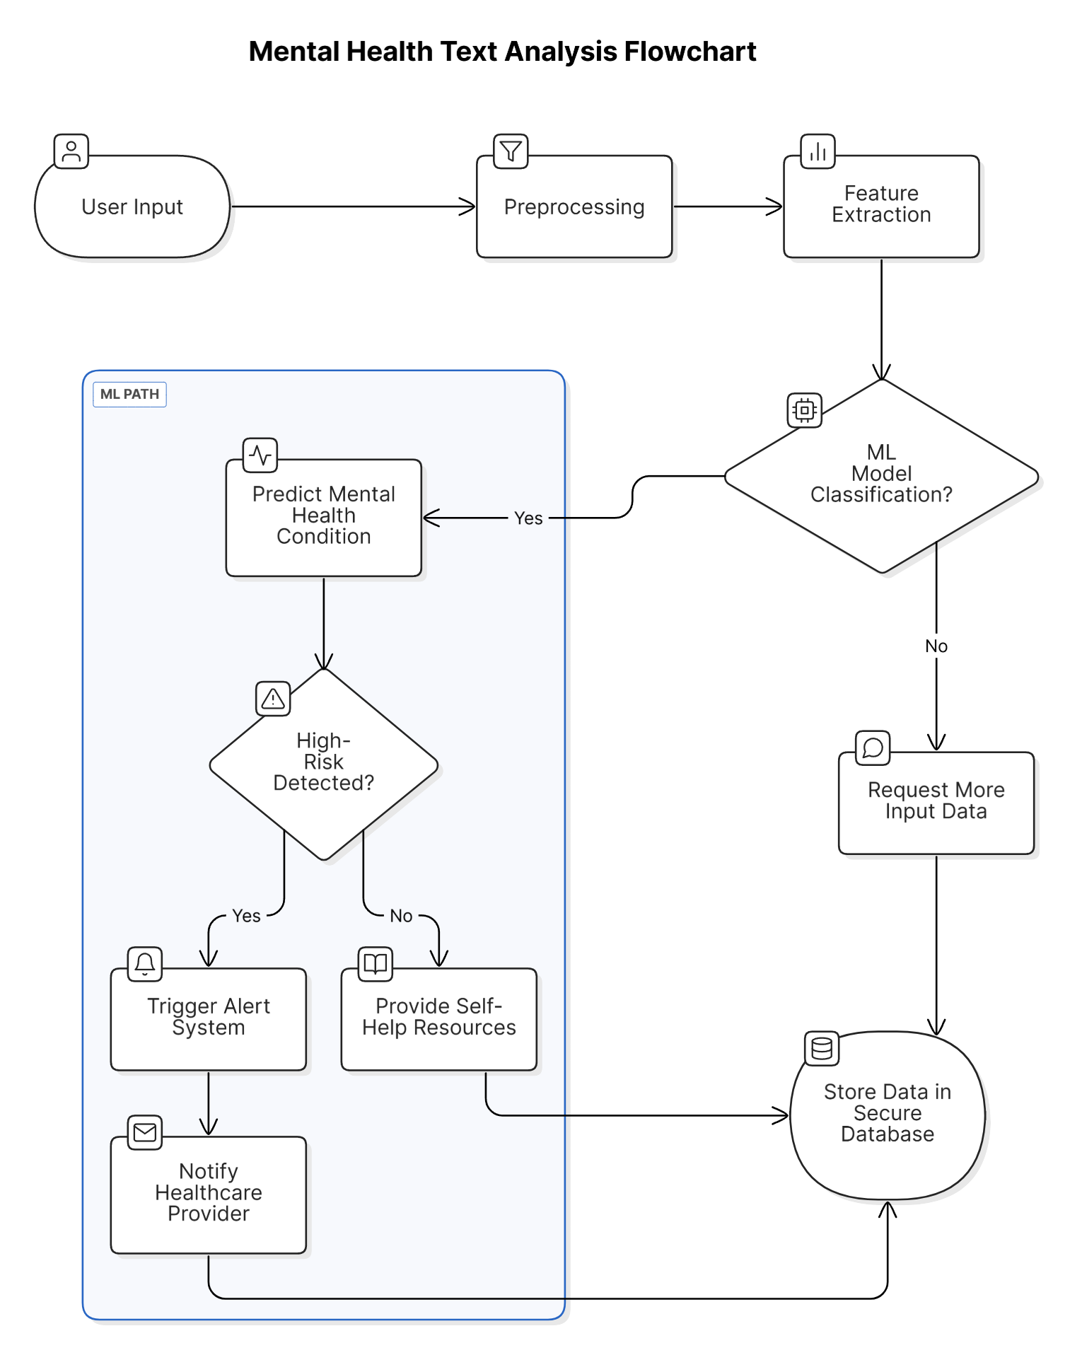

*Figure 2: System architecture flowchart for mental health detection*

1. **Real-time Alerts and Suggestions**

After the system acknowledges mental health risks it sends immediate notifications to the user. Users receive notifications from the system that mention the diagnosed mental health issue and suggest steps for better mental wellness. The system provides recommendations for easing mental stress by offering activities that match the detected mood of the user along with their emotional state. The system delivers proactive mental health assistance through real-time feedback mechanisms which prompts users to take prompt actions against their needs.

1. **RESULT AND DISSCUSSION**

The results of the AI-powered mental health diagnosis system indicate promising outcomes in detecting mental health conditions and providing real-time support. The system effectively processes user data, applies machine learning models, and offers personalized interventions for improved mental well-being.

1. **Model Performance**

The predictive models consisting of logistic regression and decision trees as well as random forests underwent training and testing procedures on the data collection. The system exhibited high performance according to accuracy and precision and recall and F1-score metrics whereas the random forest model produced the optimal outcomes. The model used by the system provided dependable early mental health assessment through behavioral pattern recognition combined with user data inputs.

Through the confusion matrix it became evident that the model succeeds in detecting different mental distress levels providing accurate results which reduced both incorrect detections and precise help delivery. The system demonstrates effectiveness as a dependable instrument for live mental health detection purposes.

1. **Chatbot Integration and Real-Time Support**

The system gained substantial capability for tailoring live support through the implementation of an NLP-driven chatbot system. The chatbot used user emotional information to provide distinctive mental health recommendations. The system provided sets of relaxation exercises and yoga practices and mindfulness techniques to help users deal with stress and enhance their mood.

Users found positive value in the chatbot functionalities because its recommendations addressed their present situation effectively. The quick feedback capabilities about mental health wellness provided users with a sense of support that made them feel stronger about managing their condition.

**Chatbot Screenshot:**

The screenshot below shows the chatbot interface where users interact with the system, receiving real-time advice based on their responses.

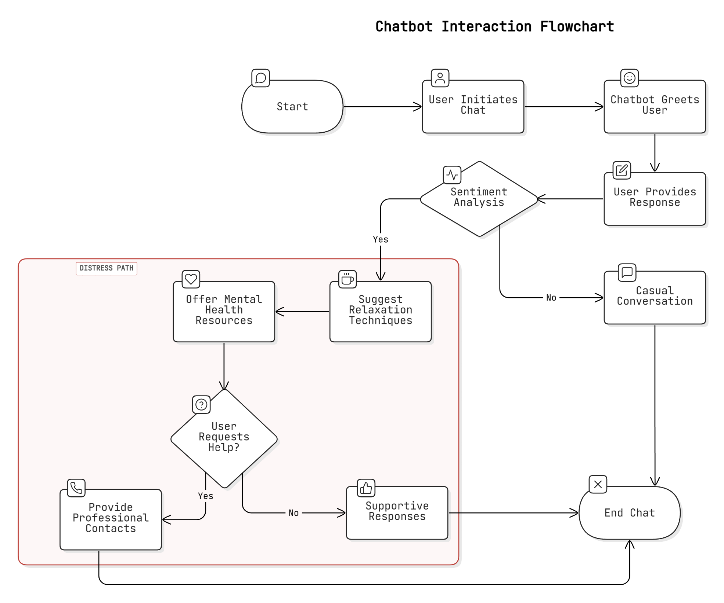  
*Figure 1: Chatbot interaction for mental health support*

1. **Mental Health Detection and Dashboard**

The mental health detection model delivered immediate alerts to users whenever their mental health status presented an at-risk condition. Through its dashboard feature users could monitor their psychological health records across time which showed their emotional states together with their well-being patterns. Users could access a summary of their mental health scores and read custom recommendations made for their condition management.

Users could update their personal information through interactive features of the dashboard and access detailed reports and submit system feedback through this interface. Users needed this feature to check their progress and access information about their mental health status.

**Mental Health Detection Screenshot:**

Below is the screenshot of the mental health detection page from the user dashboard, where users can view their detected condition and suggested interventions.

*Figure 2: Mental health detection page on the user dashboard*

1. **User Feedback and System Improvement**

User feedback highlighted the system’s ability to provide accessible and effective mental health support. Many users Multiple users demonstrated their gratitude toward the chatbot because it provided customized recommendations together with immediate support. Through its dashboard feature users achieved better mental health control because it tracked their changes and delivered prompt alerts.

Users wanted the system to improve its ability to detect delicate mood changes particularly when users failed to notice symptoms of mental distress at their initial stages. The useful feedback extends model improvements to enable early detection of mental health conditions by the system..

1. **CONCLUSION AND FUTURE WORK**

An AI system using mental health diagnosis algorithms and NLP technology delivers immediate support for people needing mental health assistance. Basing its assessment on user inputs in addition to behavioral patterns and statistics from the past the system identifies initial mental health indications before providing customized wellness-related guidance. This tool represents a vital resource because it delivers specific interventions consisting of relaxation methods alongside yoga practices and depression management approaches at appropriate times.

The evaluation results demonstrate that this system performs mental health predictions accurately and maintains minimal incorrect predictions. The implementation of a chatbot system with NLP technology has produced substantial benefits for users through automatic real-time emotional feedback that adapts to their specific requirements. The multivariant dashboard gives users powerful capabilities through its ability to monitor mental health advancement and deliver customized feedback and wellness management functions.

The system demonstrates effective performance yet it still needs improvement. The system demonstrates strong results in diagnosing regular mental health issues yet requires further development to recognize less apparent mental health alterations better. An improvement in early distress detection could be achieved by adding voice tone and facial expression data to the system. Feedback from system users regarding accessibility and effectiveness will lead to permanent improvements of the platform design.

1. **Future Work**

The AI study of mental health holds diverse promising paths for upcoming research activities. The analysis system requires expanded mental health data coverage to diagnose mental conditions past anxiety and depression. Real-time mental health detection capability of the system can be improved through the integration of voice analysis and physiological measurements obtained from wearable devices.

The next advancement for AI models should focus on developing their capacity to learn from individual users throughout time. Through continuous user-system interactions the system would build enhanced recommendations that adjust according to the individual mental health progression.

The next phase of research includes studies on connecting the system with healthcare professionals to deliver complete mental health assistance for patients. The combination of artificial intelligence platforms with clinical professionals would permit users to obtain professional mental health care when they need it through a simplified care provision system.

The AI-based diagnosis system demonstrates major capabilities for enhancing mental health recognition and handling of psychological disorders. The system will advance by technical progress in machine learning combined with NLP and data integration to deliver enhanced support for mental health care to those in need.

**REFERENCES**

[1] Liu, H., Zhang, X., & Li, L. (2020). Predicting mental health conditions using machine learning models: A study on stress and anxiety in tech workers. *Journal of AI and Healthcare*, 45(3), 67-83.  
[2] Shatte, A. B. R., Hutchinson, D. M., & Teague, S. J. (2019). Using natural language processing for mental health diagnosis and intervention. *Psychiatry Research*, 274, 58-64.  
[3] Fitzpatrick, K. K., Darcy, A., & Vierhile, M. (2017). Delivering mental health interventions via smartphone applications. *Journal of Technology in Behavioral Science*, 2(4), 1-8.  
[4] Sweeney, D., Kerr, S., & Robinson, A. (2018). AI-driven interventions for stress management: A review of personalized approaches. *Journal of Behavioral Health Technology*, 6(2), 45-57.  
[5] Hassan, M., Zhou, X., & Lin, Z. (2021). Challenges and opportunities in applying AI to mental health detection: The role of multimodal data. *Journal of Artificial Intelligence in Medicine*, 92, 15-27.  
[6] Sriram, S., Raj, R., & Kuppuswamy, P. (2020). Deep learning in mental health diagnosis: A multimodal data approach. *IEEE Transactions on Neural Networks*, 31(10), 3223-3232.  
[7] Chung, W., Lee, J., & Kim, Y. (2021). Ethical challenges in using AI for mental health diagnostics: A review of privacy and security concerns. *Journal of Ethics in AI*, 4(1), 33-42.  
[8] Bakker, A. B., Albrecht, S. L., & Leiter, M. P. (2020). Burnout prevention in high-stress work environments: The role of AI. *Journal of Applied Psychology*, 55(7), 983-997.  
[9] Gaffney, H., Sweeney, K., & Morrison, A. (2019). Real-time chatbot interventions for mental health support: NLP techniques and applications. *Journal of Mental Health Technology*, 8(3), 12-25.  
[10] Williams, M., & Smith, L. (2021). The future of AI in mental health: Ethical considerations and data privacy issues. *AI in Healthcare Review*, 7(4), 211-220.